**DAILY ONLINE ACTIVITIES SUMMARY**

|  |  |  |  |  |  |  |  |  |
| --- | --- | --- | --- | --- | --- | --- | --- | --- |
| **Date:** | **24/06/2020** | | | | | **Name:** | **Shwetha** | |
| **Sem & Sec** | **8th B** | | | | | **USN:** | **4AL16CS101** | |
| **Online Test Summary** | | | | | | | | |
| **Subject** | | **-** | | | | | | |
| **Max. Marks** | | **-** | | **Score** | | | **-** | |
| **Certification Course Summary** | | | | | | | | |
| **Course** | **AWS IOT** | | | | | | | |
| **Certificate Provider** | | | **AWS** | | **Duration** | | | **2hr** |
| **Coding Challenges** | | | | | | | | |
| **Problem Statement:**  **Program to make a simple calculator.** | | | | | | | | |
| **Status: Solved**  **Solution link: https://github.com/alvas-education-foundation/Shwetha-** | | | | | | | | |
| **Uploaded the report in Github** | | | | | **Yes** | | | |
| **If yes Repository name** | | | | | **Shwetha-** | | | |
| **Uploaded the report in slack** | | | | | **Yes** | | | |

Certification Course Details:

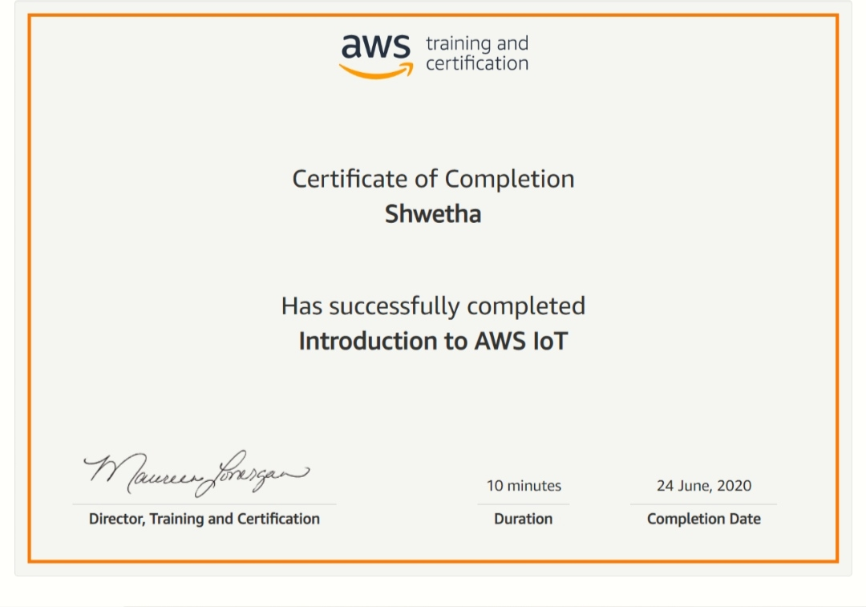

*Coding Challenges Details:*

defadd(x,y):

returnx+y

defsubtract(x,y):

returnx-y

defmultiply(x,y):

returnx*y

defdivide(x,y):

returnx/y

print("Selectoperation.")

print("1.Add")

print("2.Subtract")

print("3.Multiply")

print("4.Divide")

whileTrue:

choice=input("Enterchoice(1/2/3/4):")

ifchoicein('1','2','3','4'):

num1=float(input("Enterfirstnumber:"))

num2=float(input("Entersecondnumber:"))

ifchoice=='1':

print(num1,"+",num2,"=",add(num1,num2))

elifchoice=='2':

print(num1,"-",num2,"=",subtract(num1,num2))

elifchoice=='3':

print(num1,"*",num2,"=",multiply(num1,num2))

elifchoice=='4':

print(num1,"/",num2,"=",divide(num1,num2))

break

else:

print("InvalidInput")